Dashboard Application

Ebony Anderson
Southern New Hampshire University
CS 340 Client/Server Development
Instructor: Timothy Hawkins
April 19, 2026

Project Overview
For this project, I developed a full-stack dashboard application for Grazioso Salvare, an organization that specializes in training rescue dogs for life-saving missions. The purpose of this dashboard is to help users quickly identify dogs that meet specific criteria for different types of rescue training using real shelter data.
Instead of manually searching through thousands of records, this application allows users to filter, visualize, and interact with the data in a way that is fast, intuitive, and easy to understand. This directly supports the client’s goal of reducing training time and minimizing user error.

Application Design
This dashboard can be thought of as a smart filtering and visualization tool. The database stores all raw animal data, while the dashboard allows users to apply filters and instantly see results through visualizations and a data table.
This application follows the Model-View-Controller (MVC) design pattern:
- Model: MongoDB database storing animal records
- View: Dashboard interface (data table, charts, and map)
- Controller: Python CRUD module and Dash callbacks
When a user selects a filter (such as Water Rescue), the system:
- Executes a database query
- Retrieves only matching records
- Updates all dashboard components in real time

Technologies Used and Rationale
Each technology was selected based on its strengths for this type of application:
MongoDB:
Chosen for its flexibility in handling large, unstructured datasets such as animal records with varying attributes.
Python:
Serves as the core programming language to connect the database, process data, and control application logic.
Dash (Plotly):
Enables the creation of interactive dashboards without requiring front-end JavaScript development.
Pandas:
Used to clean, structure, and manipulate data before displaying it in the dashboard.
Dash Leaflet:
Provides an interactive map to visualize geographic data using latitude and longitude coordinates.

Dashboard Features
The dashboard includes all required components from the specification document:

1. Interactive Filtering
Users can filter dogs by rescue type:
- Water Rescue
- Mountain/Wilderness Rescue
- Disaster/Tracking
- Reset (All data)
Each filter applies specific criteria such as breed, sex, and age based on client requirements.

2. Interactive Data Table
- Displays filtered results instantly
- Supports sorting and scrolling
- Updates dynamically when filters change

3. Breed Distribution Chart (Pie Chart)
- Shows top breeds clearly
- Groups smaller categories into “Other” for readability
- Updates based on selected filter

4. Geolocation Map
- Displays animal locations using latitude/longitude
- Updates when a row is selected
- Helps visualize where dogs are located geographically

5. Breed Gender Chart (Bar Chart)
- Shows distribution of dogs by sex and outcome
- Uses sorting to highlight the most common categories
- Updates dynamically with filters

Challenges and How I Solved Them

1. Too Much Data in Charts
Problem:
The pie chart originally had too many categories, making it unreadable.
Solution:
I grouped smaller categories into “Other”, making the chart clean and professional.

2. Dashboard Not Updating Properly
Problem:
At first, components didn’t sync when filters changed.
Solution:
Used Dash callbacks correctly so:
- Table
- Charts
- Map
all update at the same time

3. MongoDB _id Error
Problem:
MongoDB returns an _id field that breaks the table.
Solution:
Removed it using:
df.drop(columns=['_id'], inplace=True)

How to Run the Project
Follow these steps to reproduce the project:
- Open Codio and launch Jupyter Lab
- Open ProjectTwoDashboard.ipynb
- Run all cells (Kernel → Restart & Run All)
- The dashboard will launch in a new tab
- Use the dropdown filter to interact with the data

How This Meets the Client Requirements
This dashboard meets all required functionality:
✔ Interactive filtering options
✔ Dynamic data table
✔ Geolocation map
✔ Additional chart (pie + bar)
✔ User-friendly layout
✔ Branding (logo + name)
As shown in the specification mockups, all components update based on user selection.

Screenshots of Dashboard Functionality
The following screenshots demonstrate the successful execution of all required dashboard components.

Figure 1: Default Dashboard View (All/Reset)
This screenshot shows the dashboard in its default state with all records displayed. The data table, pie chart, geolocation map, and bar chart are all visible and populated, providing a complete overview of the dataset.
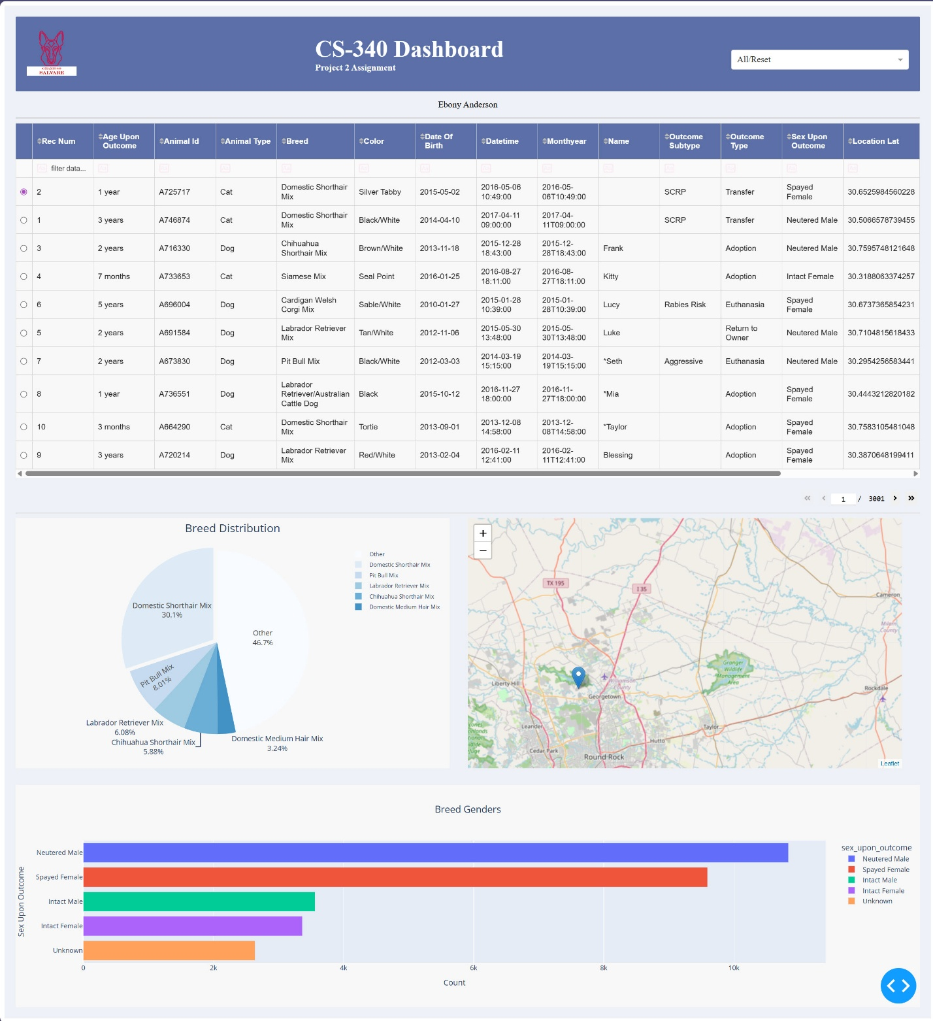

Figure 2: Disaster/Tracking Filter Applied
This screenshot demonstrates the Disaster/Tracking filter. The data table, pie chart, map, and bar chart all update dynamically to display only relevant dog breeds such as Bloodhound, Rottweiler, and German Shepherd.
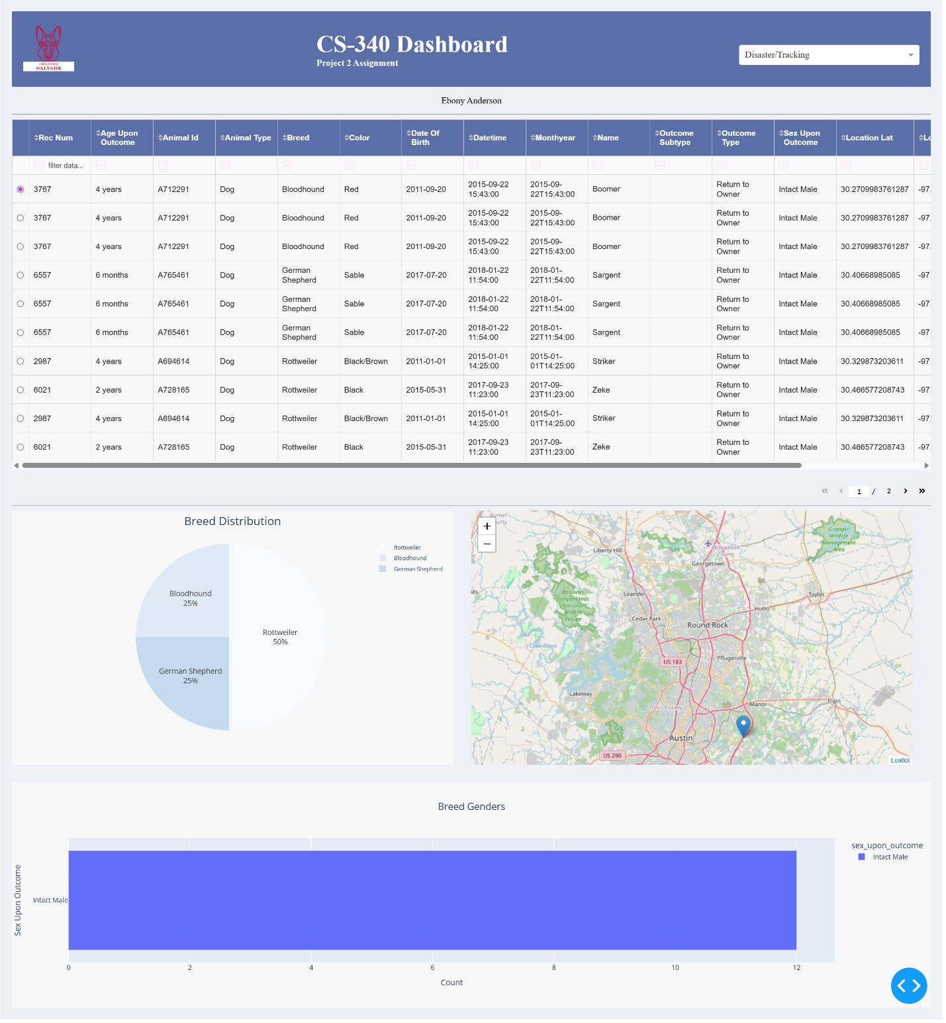

Figure 3: Mountain/Wilderness Filter Applied
This screenshot shows the Mountain/Wilderness Rescue filter applied. The dashboard updates dynamically to display only breeds suitable for this category, such as Alaskan Malamute, Siberian Husky, and German Shepherd. All components reflect the filtered dataset.
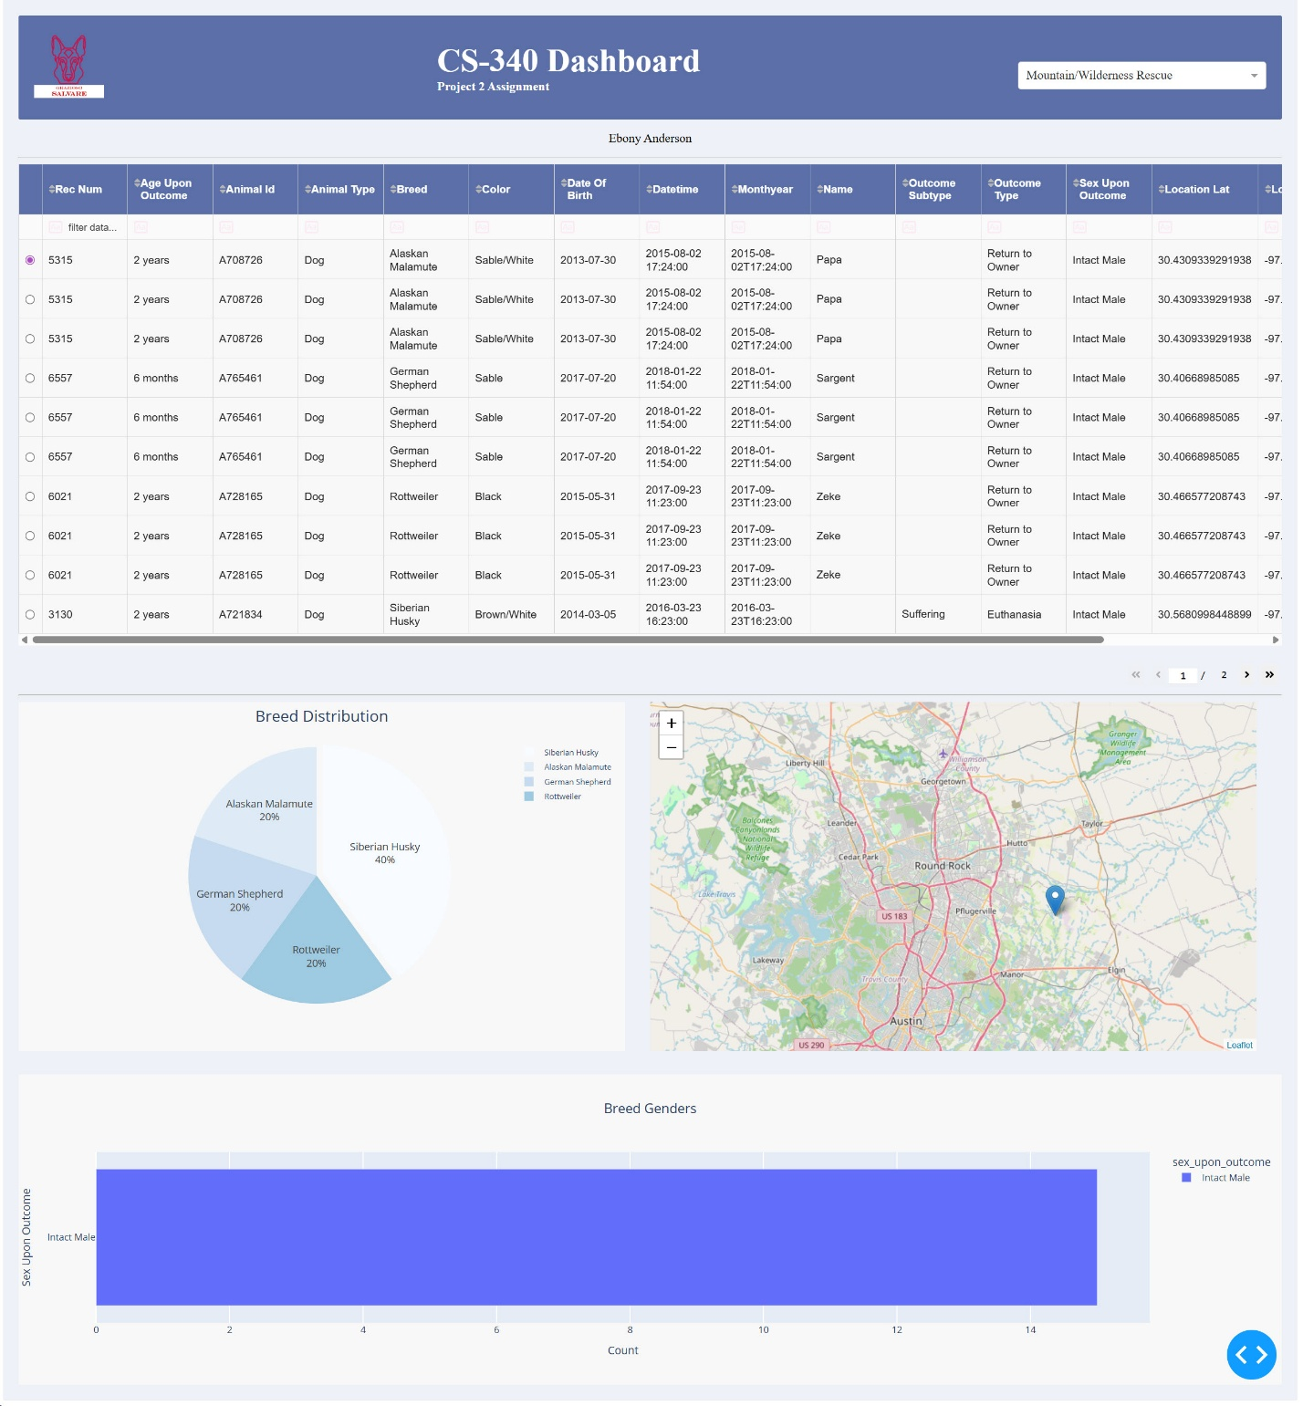

Figure 4: Water Rescue Filter Applied
This screenshot demonstrates the Water Rescue filter. The dashboard updates to display only Labrador Retriever Mix dogs, which results in a simplified pie chart and a focused data table. This highlights how filtering narrows the dataset to a specific rescue type.
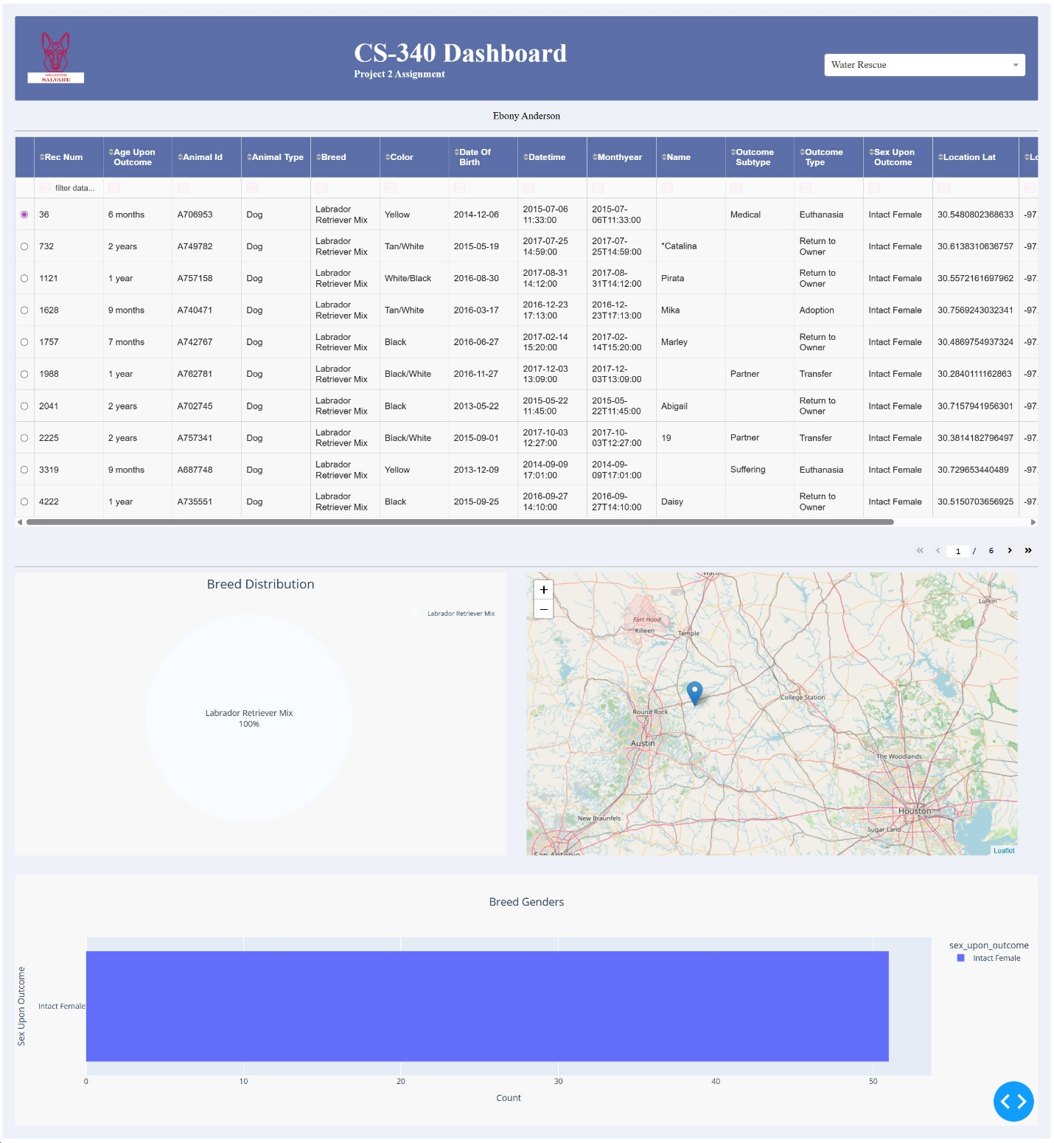

Figure 5: Interactive Filter Dropdown
This screenshot highlights the dropdown filter component. Users can select rescue categories such as Water Rescue, Mountain/Wilderness Rescue, or Disaster/Tracking, and the dashboard dynamically updates all components based on the selected option.
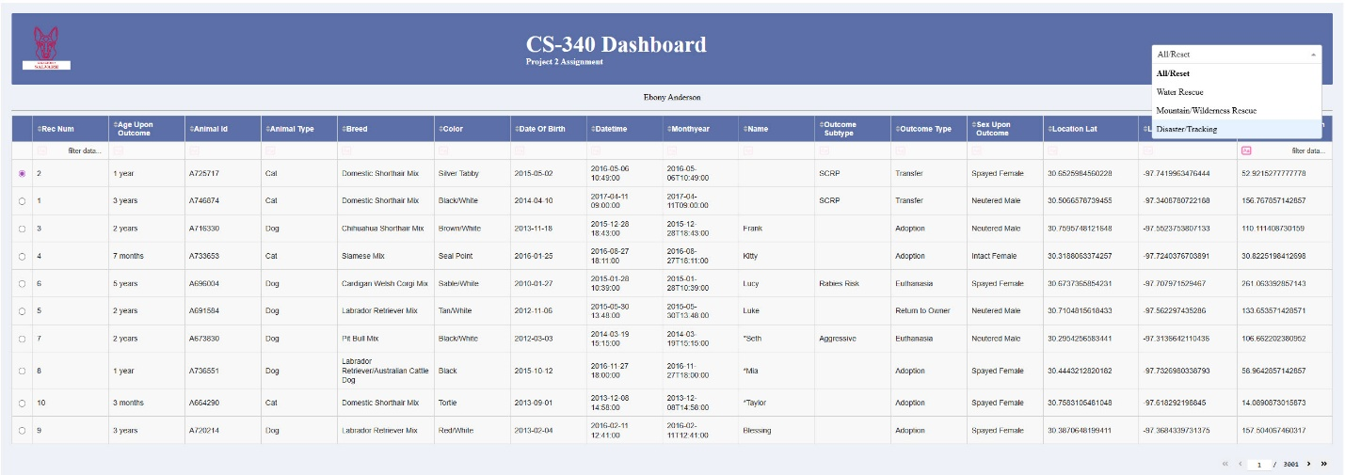

Figure 6: Interactive Data Table
This screenshot highlights the interactive data table displaying animal records. The table supports scrolling, sorting, and dynamic updates based on selected filters, allowing users to efficiently explore and analyze the dataset.
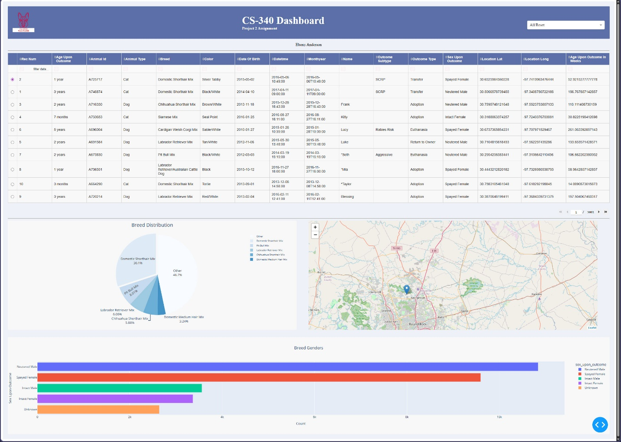

Figure 7: Breed Distribution Chart (Pie Chart)
This screenshot displays the pie chart visualizing the distribution of animal breeds. Smaller categories are grouped into “Other” to improve readability. The chart dynamically updates based on selected filters, allowing users to quickly identify dominant breeds.
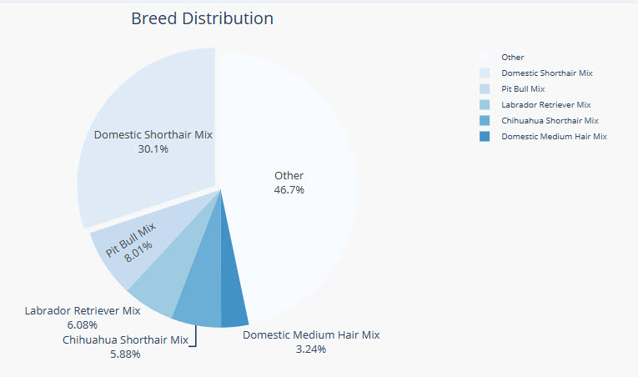

Figure 8: Geolocation Map
This screenshot displays the geolocation map of animal records using latitude and longitude coordinates. Each marker represents an individual animal, and users can interact with the map to view additional details such as the animal’s name. The map dynamically updates based on selected filters.
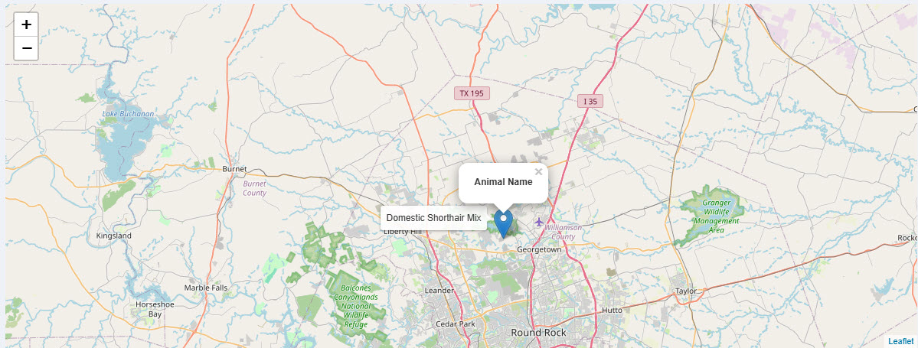

Figure 9: Breed Gender Chart (Bar Chart)
This screenshot shows the bar chart displaying the distribution of animals by sex upon outcome. The chart is sorted for clarity and updates dynamically with filters, making it easy to compare gender-related trends.
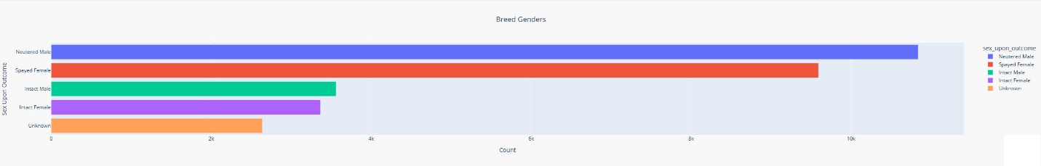

Final Thoughts
This project also demonstrates the importance of integrating backend data processing with frontend visualization to create tools that are both technically efficient and user-focused. The ability to dynamically filter and visualize data provides a significant advantage over static reporting methods.

